Setup pic 1

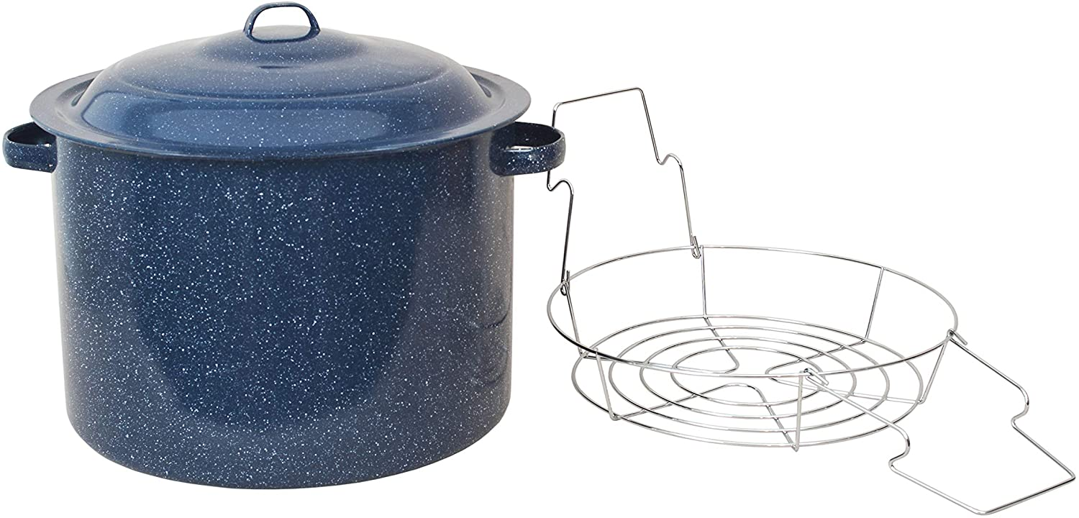

https://i.imgur.com/dy5z6WE.jpeg

Setup pic 2

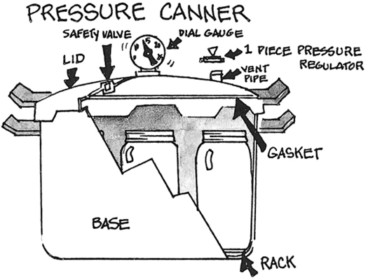

https://i.imgur.com/YqUQ6ML.jpeg

Setup pic 3

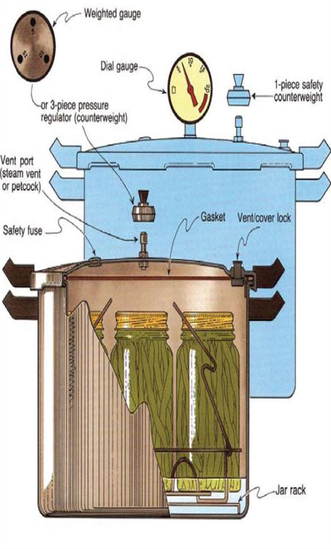

https://i.imgur.com/6WjbKvE.png